one-day events & activities
session 1. Fitness training in the park

Q. Rajkumar Dixit
 |  |  | overview

to the presenter
Thank you for being willing to make a difference in your community. The Life Hope Center is dedicated to helping people improve their lives through gaining knowledge and applying that knowledge to their lives.

Below are the steps, as well as some helpful hints, to make your presentation a success.

course kit contents:
- Presenter’s guide
- PowerPoint slides

Materials Needed
- Leader’s notes
- PowerPoint
- Computer (for the PowerPoint presentation)
- Projector and screen
- Tables and chairs
- Pens or pencils
- Sound system (for large classes)

Tips and Guidelines
1. |  |  | Come prepared.  Review the entire content and handout materials before the session. Arrive early for your presentation. Set up your equipment and test everything before the participants arrive.
2. |  |  | Greet the participants as they arrive.  One of our goals is to build relationships within the community. Greeting people as they enter puts them at ease and can open doors for further dialogue.
3. |  |  | Start on time.  The presentations are designed to be less than 1.5 hours. Honor that time frame.
4. |  |  | Welcome students and introduce yourself.  This introduction should take only 30 to 60 seconds.
5. |  |  | Introduce the topic of the presentation.  A brief introduction appears in the script under slide 2. Keep it short. Introductions should get the participants’ attention, not bore them.

6. |  | Distribute the participant worksheet for note taking.
7. |  | Give the PowerPoint presentation.
8. |  | Introduce and distribute the quiz.  Detailed instructions are given in the script. Have the participants work in small groups of two to four, discussing and completing the quiz together. (If the nature of your group warrants it, lead the discussion of the quiz questions from the front, soliciting responses from the participants.) Give the participants about 20 minutes to complete the quiz. Monitor the participants’ progress, adjusting the time as needed to allow them time to complete the worksheet. Then call them back together as a group and discuss the answers using the answer key.
9. |  | Closing remarks and reminder.  Introduce the next session’s topic, and remind them of the date, and time of the session.
10. |  | Thank the participants for coming and visit with them as they are leaving.

WELCOME

 | Slide 1
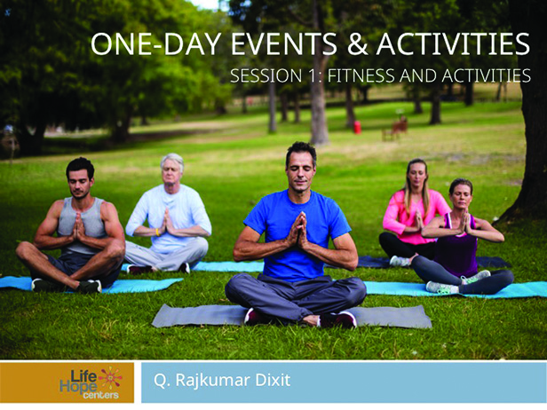 |  | Fitness Training in the Park provides a free service to the community and is held a neutral location. This kind of community program can attract a wide range of participants and build lasting friendships.
 | Planning the program
 | Slide 2
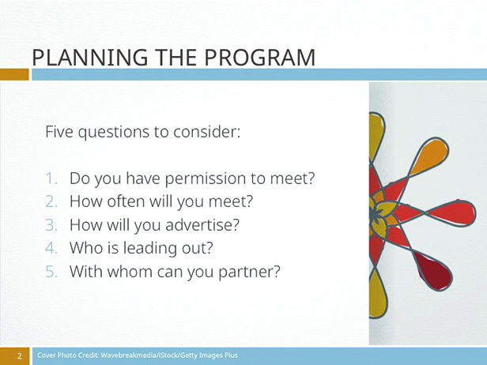 |  | Five questions to consider:  - Do you have permission to meet?  - Determine how long the course will run.  - How will you advertise?  - Who’s leading?  - With whom can you partner?
 | 1. Permission
 | Slide 3
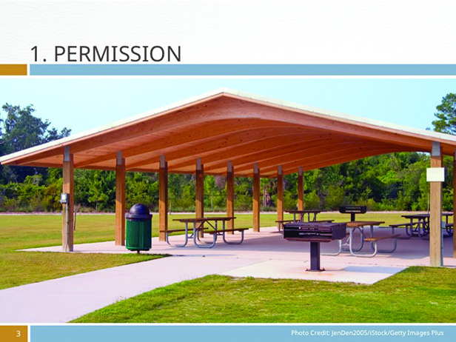 |  | Do you have permission to meet? Ask the city if there are any special regulations or permits required to use a particular park on a regular basis.

 | 2. Length
 | Slide 4
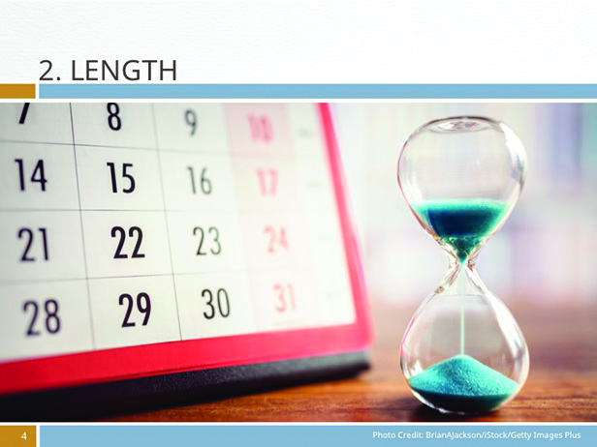 |  | Determine how long the course will run. How often will the group will meet, once a week or twice, and for how many weeks. You may want to have a start and end date. For example, offer a 12-week session and then take a break for a month before starting up again. Determine how long you want each session to run—30 minutes? 90 minutes?
 | 3. Advertising
 | Slide 5
How will you advertise? How will you publicize this event in the community? Who will be your target audience? The following are some groups to identify and build bonds with:
- New mothers
- Church groups
- Seniors or young adults
 | 4. Leader
 | Slide 6
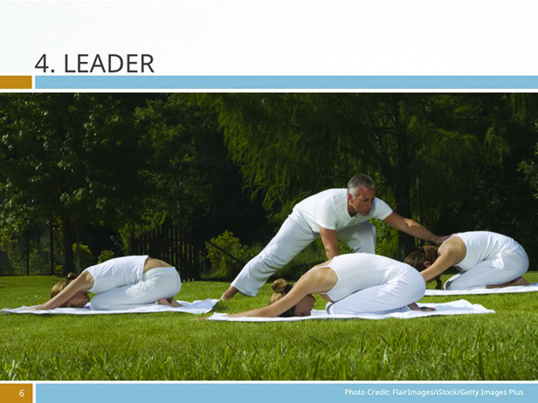 |  | Who’s leading? Who will be the exercise leader? Is there someone in your religious community who can lead the sessions? Is there a local exercise coach at a local gym who would be willing to lead the class?

 | 5. Partners
 | Slide 7
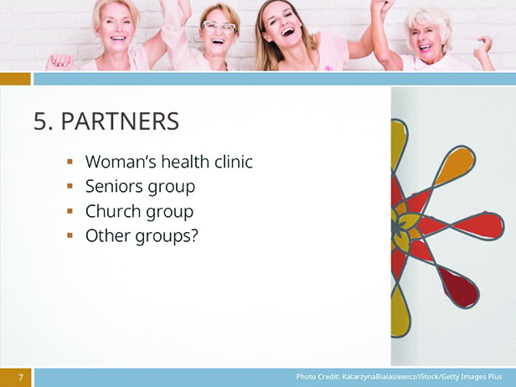 |  | With whom can you partner? Are there other organizations in the community with whom you can build relationships such as a local woman’s health clinic or a group that works with seniors? Is a neighboring church group interested in helping sponsor the program?
 | Getting started
 | Slide 8
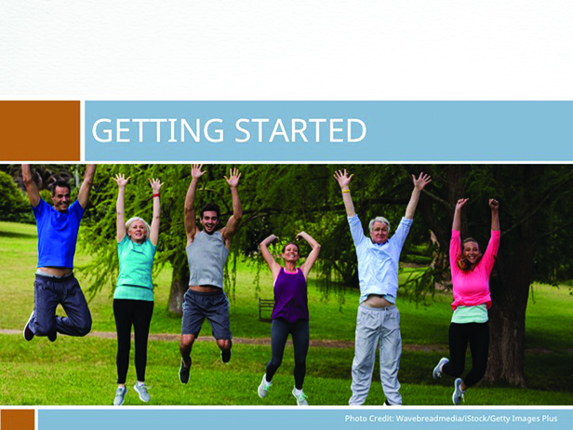 |  | The purpose of the Fitness Training in the Park program is to get people moving and remain active. You can even start with a walking club to generate interest.
 | Target program
 | Slide 9
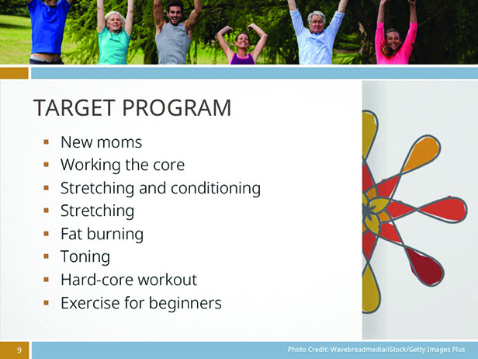 |  | Decide what kind of exercise regimen you will offer. Depending on your particular audience, age, and gender, the kind of exercise program you offer will determine who you attract. Here are some popular exercise regimens that can work in a park.  - New moms exercise class to help lose weight gained during pregnancy  - Working the body’s core  - Stretching and conditioning  - Stretches for relaxation and fitness  - Fat burning  - Toning muscles  - A 60-minute hard-core workout  - Exercise for beginners
 | Sample and sign up
 | Slide 10
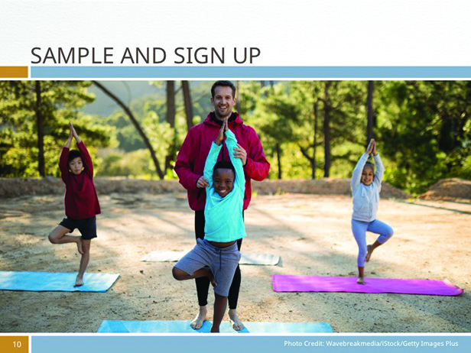 |  | Invite the public to join a free fitness session on a Sunday morning, and then encourage those who attend to sign up for the full course. Limit class size to 20 people, and give participants a tee shirt that says, “I Survived Fitness in the Park, Sponsored by the Life Hope Center” upon completion.
 | Follow-up Activities & Programs
 | Slide 11
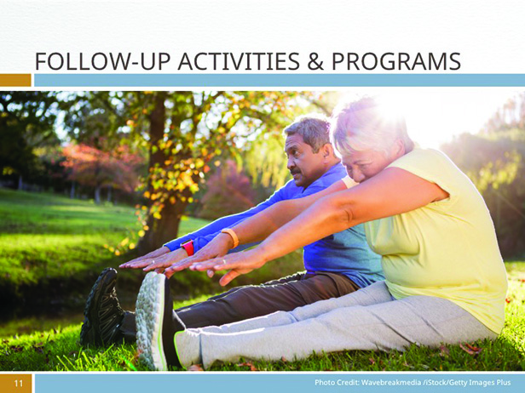 |  | As you build rapport with the attendees, begin to plan other activities or seminars. In addition, some of the new participants may be interested in organizing a health fair through the Life Hope Center. You can also invite the participants to attend healthful cooking or nutrition classes. Class members will tell you what they’re interested in, so ask.

 | Important social interaction
 | Slide 12
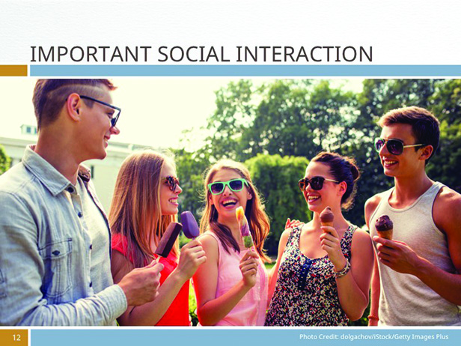 |  | One of the benefits of organizing a fitness program is to introduce people to other like-minded individuals, so plan a social interaction component after every exercise session. You can have a refreshment station that allows people to linger after the workout to socialize and build community.
 | Other Fitness & Activities ideas
 | Slide 13
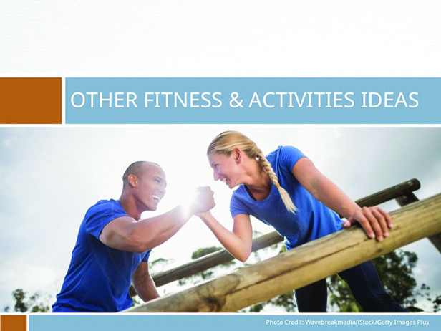 |  | - Sponsor a community 5K run  - Sports on Sunday
 | Sponsor a Community 5k run
 | slide 14
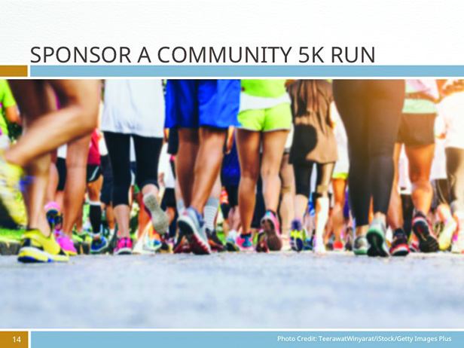 |  | Mini-marathons are popular and can be a great fundraiser for non-profit organizations. Plan a 5k event that starts and finishes at your Life Hope Center. Allow runners to sign up to be sponsored by friends and family to raise funds for the center or  charge a small fee for those who wish to run just for the fun.  Publicize that all proceeds from the race will benefit local non-profit organizations or help fund specific projects in the community. Host an awards ceremony after the run, and give awards for various categories of runners, such as under 10 years, 10 to 17 years, 18 to 40 years, 40 to 65, 66 to 79, and 80-plus years for both men and women. You might also wish to include awards for those running with disabilities.
 | Sports on Sunday
 | slide 15
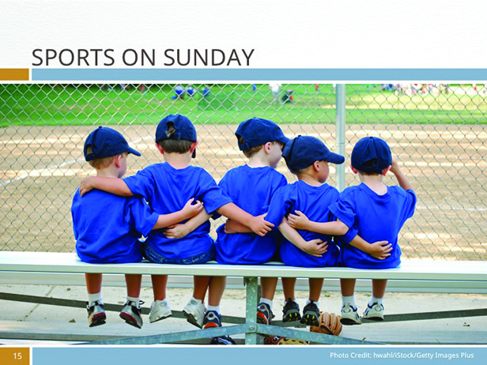 |  | Most communities hold community sporting events such as soccer and baseball games on Saturdays, which eliminates Jewish and Adventist members of the community as well as anyone who has regular obligations on that day. If your community has an interest, initiate a Sports on Sunday program for the members of the community who otherwise wouldn’t take part in the Saturday games. Members of one church who formed a sports league to play on Sundays found their children’s teams grow from 40 kids to more than 100 in two seasons. As a result, the local town loaned the use of two soccer fields free of charge to support the program.  To form such a program, scour the neighborhood for sports-minded adults who can mentor the kids’ teams, provide referees and coaches, and seek out community sponsors that can provide equipment, tee shirts, and a space to play in exchange for a little publicity.

slide 16
