Q. Rajkumar Dixit
one-day events & activities
session 4. families first

 |  |  |  | overview

course kit contents:
- Presenter’s guide
- PowerPoint slides

Materials Needed
- Leader’s notes
- PowerPoint
- Computer (for the PowerPoint presentation)
- Projector and screen
- Tables and chairs
- Pens or pencils
- Sound system (for large classes)

Tips and Guidelines
1. |  |  |  | Come prepared.  Review the entire content and handout materials before the session. Arrive early for your presentation. Set up your equipment and test everything before the participants arrive.
2. |  |  |  | Greet the participants as they arrive.  One of our goals is to build relationships within the community. Greeting people as they enter puts them at ease and can open doors for further dialogue.
3. |  |  |  | Start on time.  The presentations are designed to be less than 1.5 hours. Honor that time frame.
4. |  |  |  | Welcome students and introduce yourself.  This introduction should take only 30 to 60 seconds.
5. |  |  |  | Introduce the topic of the presentation.  A brief introduction appears in the script under slide 2. Keep it short. Introductions should get the participants’ attention, not bore them.
6. |  |  |  | Distribute the participant worksheet for note taking.
7. |  |  |  | Give the PowerPoint presentation.
8. |  |  |  | Introduce and distribute the quiz.  Detailed instructions are given in the script. Have the participants work in small groups of two to four, discussing and completing the quiz together. (If the nature of your group warrants it, lead the discussion of the quiz questions from the front, soliciting responses from the participants.) Give the participants about 20 minutes to complete the quiz. Monitor the participants’ progress, adjusting the time as needed to allow them time to complete the worksheet. Then call them back together as a group and discuss the answers using the answer key.
9. |  |  |  | Closing remarks and reminder.  Introduce the next session’s topic, and remind them of the date, and time of the session.
10. |  |  |  | Thank the participants for coming and visit with them as they are leaving.

WELCOME

 | Slide 1
 |  | An afterschool tutoring program is an excellent way to build goodwill in your community. Many children are left to themselves because both of their parents must work. An afterschool program provides parents with a good environment where their children can study and relax.
 | Tutoring & mentoring
 | Slide 2
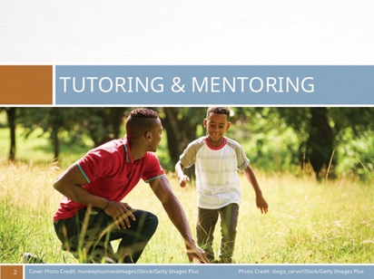 |  | There are five areas you should consider before starting a mentoring program.
 | Five areas of consideration
 | Slide 3
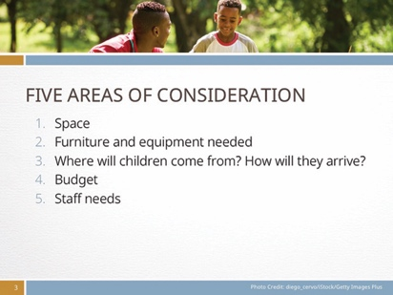 |  | - How much space will such a program demand (one or more large rooms, a kitchen/kitchenette, bathrooms)?  - What furniture and equipment will it need (desks, chairs, computers, play equipment)?  - Where will children come from? (Local primary or middle schools or a neighborhood with lots of children who need afterschool care.) How will they arrive? Should a designated volunteer meet the children at their school and walk them to the Center?  - A budget for the building, equipment, supplies, and employees or volunteer mentors.  - Staff needs.
 | Recruiting volunteers
 | Slide 4
 |  | One of the greatest challenges in sustaining a volunteer-led organization is recruiting and retaining volunteer mentors. Volunteers have full lives, careers, and family obligations outside of the tutoring program. They are often balancing many areas of their life at once. Recognize the value of the time they are giving to the organization.
 | 7 steps to recruiting & retaining mentors
 | Slide 5
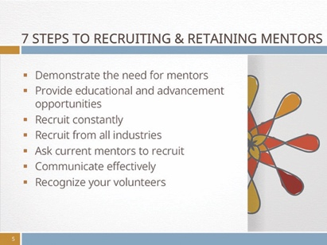 |  | - Demonstrate the need for mentors through story or picture. People are often compelled through an inspiring story. Show a picture of a successful adult who families First benefited by having a mentor. Ask a young person or a parent to tell their personal story about how they (or their child) defied the odds and how their life has improved because someone cared enough to mentor them.  - Provide educational and advancement opportunities. Volunteers want to be the best at what they do. They are typically overachievers; hence they are using their extra time to help others. Offer your volunteers continuing educational opportunities, such as giving them a book or magazine article to read that will help them grow. Invest in them as you would in a paid employee.  - Recruit constantly. Use every opportunity, even in casual conversations with people around you to cast the vision and recruit new volunteers. Even if you have the luxury of having many volunteers, keep recruiting and sharing your need for highly effective mentors.  - Recruit from all industries. Many organizations and businesses encourage their employees to volunteer in the community. Some companies will pay their employees’ wages to serve their community for two or three hours a month because it generates goodwill and benefits the community where the business is located. Ask the human resources departments of local companies if they have a volunteer program you can partner with.  - Ask your current mentors to recruit for you. Turn your volunteers into mentoring evangelists. Ask them to make a goal of recruiting two friends to serve as mentors also. If your volunteers find their experience satisfying, they will be happy to invite others to experience the same rewards.  - Communicate effectively. Be clear from the beginning on what your expectations are. Treat your volunteers like employees by giving them responsibilities.  - Recognize your volunteers for their courageous work. Everybody appreciates recognition, whether they are a paid employee or a volunteer. Find new and  - creative ways to show your appreciation to your volunteer team.
 | How to be a successful mentor
 | Slide 6
JOB DESCRIPTION
Our goal is for every child to recognize his or her full potential. While this is an afterschool program that works with children on their homework and tutors them when needed, our greater mission is to mentor every child. More than teaching, we are focusing on the whole child. Paul Tough, author of How Children Succeed: Grit, Curiosity, and the Hidden Power of Character, argues that children need more than cognitive (intellectual) skills to succeed. The author suggests that children need to develop persistence, self-control, curiosity, conscientiousness, grit, and self-confidence—what the author refers to as character.
Your goal is to help children develop character. If children can believe in themselves, based on your contribution as a mentor, you have succeeded.

 | WHAT SHOULD CHILDREN EXPECT FROM THEIR MENTORS?
 | Slide 7
 |  | Practical Skills. Teach them practical skills to get through life. Rather than pacifying or entertaining a child and telling that everything is going to be OK, show them strategies on how to deal with everyday situations.
 | Slide 8
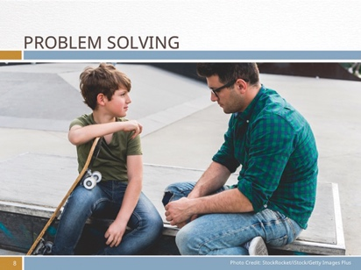 |  | Problem Solving. Help them work through their problems. Talk to them about their challenges and help them identity solutions. Follow up with them and ask them how it went, so they can determine the best way to deal with their problems.
 | Slide 9
 |  | Moral Compass. Let them know what is right and wrong. Children need you to help them develop a moral compass. Show them how to live a better life and make wise decisions.
 | Slide 10
 |  | Future Choices. Introduce them to future choices. Talk to them about future careers and educational options. Help them believe that they have a bright future ahead if they choose wisely.

 | Slide 11
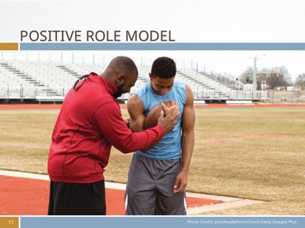 |  | Positive Role Model. Be a positive role model. Live your life as an exemplary citizen. Show them what kind of person they should be by being that person.
 | Slide 12
 |  | Homework. Help them with their homework. One of the reasons why they are involved in the after-school program may be because they need educational support. They may be embarrassed that they can’t understand their homework. Don’t give up on them, but show them to how to address their challenges.
 | Safety protocols
 | Slide 13
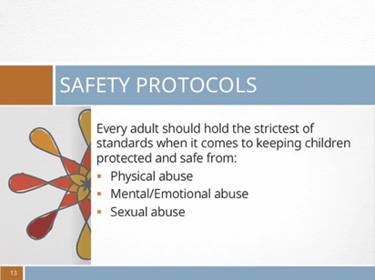 |  | SAFETY PROTOCOL FOR VOLUNTEERS WORKING WITH CHILDREN  Mentoring children is a noble aspiration. But keeping children safe is paramount. Every child deserves to thrive in a protected environment. Every adult should hold the strictest of standards when it comes to keeping children protected and safe. And one of the greatest threats to children is abuse.  Abuse comes in several forms: physical (beating, bruising a child), mental or emotional (taunting, demeaning, shouting, or threatening a child), and sexual (inappropriately touching or influencing a child sexually). And sadly, most child abuse occurs in what should be a safe environment—at home, in the care of a trusted family or friend, or at school.  It’s important to be aware of signs of abuse and to address the issue properly when it occurs.
 | slide 14
 |  | Physical Abuse. Physical abuse is perhaps the easiest to identify. A child may have unexplained bruises or other injuries. “Oh, she’s clumsy,” a parent may say, or “he fell down.” But if the injuries occur frequently, or the child shows signs of fear of the parent or guardian, be observant. If the child admits to having been mistreated by an adult or bullied by an older child, it’s your duty to report your observations to the director or to the authorities who can act on the child’s behalf. But doing so places the child in jeopardy, and many children will refuse to face their accusers.
 | slide 15
 |  | Mental or Emotional Abuse. A child who is mentally or emotionally abused may be harder to identify. He or she may cower in the presence of another adult, flinch or exhibit other defensive behavior if a caretaker or parent comes toward them. They often will appear to lack confidence, hesitate to speak up, or not ask for help to do simple tasks. It’s important to gently win the trust of such children and allow them to open up to you. If abuse is identified, it may be necessary to speak to the authorities regarding the child’s allegations. But be aware that most adults caught in abusive situations will deny their own or someone else’s abusive actions, and often this can put the child into greater danger.

 | slide 16
 |  | Sexual Abuse. Sexual abuse involves inappropriately touching or fondling a child, or rape. Most child sexual abuse occurs by a family member or friend of the child—someone the child should be able to trust. It can include inappropriate comments, exhibitionism, or sexually touching the child. Most often the abuser convinces the child to “keep their secret” or threatens that if they tell their secret, bad things will happen. Thus, much sexual abuse isn’t reported until long after it’s occurred or has been occurring for a long time. Children often don’t realize that what the perpetrator is doing to them is wrong and that they’re victims of a crime. Thus, it’s critical to note any signs that indicate that something abnormal is happening in the child’s life:
 | slide 17
Thus, it’s critical to note any signs that indicate that something abnormal is happening in the child’s life:
- A child is unwilling or not enthusiastic about going to a particular place or being with a particular person.
- A child shows unusual interest in genitals of other people or of animals.
- A child may exhibit fondness in inappropriate ways, such as French kissing or touching another person’s genitals.
- A child is diagnosed with a sexually transmitted disease (STD).

- A child refuses to change clothes in front of others such as preparing for a swimming class.
- A child isolates him/herself.
- A child fears closed areas such as bathrooms or closets.
- A child exhibits a sudden decrease in or loss of appetite.
- A child exhibits lots of new fears and needs more reassurance than in the past.
- A child shows fear of going home after school or continually runs away from home.
- A child’s artwork involves sexually explicit body parts or contains themes associated with sexual abuse.
- Torn or bloody underclothing.
- Lacerations or bruises or injury or pain in the genitals.
Any of these symptoms should alert the staff that something might be wrong. Observe and make note, and if evidence warrants it, report the suspected abuse to the authorities.
 | Appropriate interaction
 | Slide 18
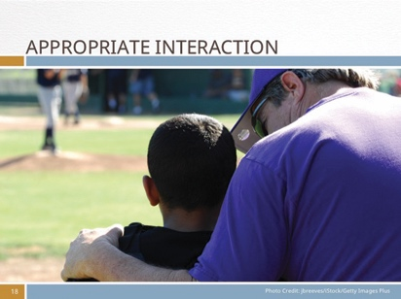 |  | HOW TO APPROPRIATELY INTERACT WITH CHILDREN  Children need loving adults in their lives to help them feel accepted and confident. They thrive on attention and interaction with respectful and gentle adults. So how should you interact with children?  Appropriate touch:  - Take a child by the hand to lead them.  - Give a “side” hug or a “shoulder” hug (avoiding contact below the shoulder level).  - Pat a child on the hand or back to affirm them. (Some cultures consider touching a child’s head as taboo, while others consider it a blessing. Avoid head-touches until you’re sure what the culture permits or forbids.)  - If necessary, hold a child gently but firmly by the shoulder to keep their attention as you explain something.
 | inAppropriate interaction
 | slide 19
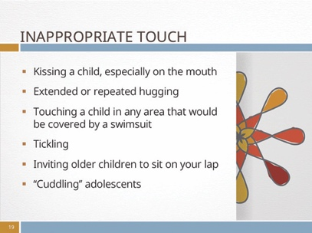 |  | - Kissing a child, especially on the mouth.  - Extended or repeated hugging  - Touching a child in any area that would be covered by a swimsuit.  - Tickling.  - Inviting older children to sit on your lap.  - “Cuddling” adolescents.
 | Obligation to report
 | slide 20
Many governments require any person who has sufficient reason to believe that a child (or children) are in need of protection to report this matter to the child welfare agency. Ministers, teachers, and medical professionals are required by law to report abuse. If you have a concern about a child’s safety,
please report it to the appropriate child welfare agency or to the director of the Life Hope Center.
 | Planning a summer day camp
 | slide 21
 |  | Planning a summer day camp for your community is a gift to families. Many parents don’t have many options for full-time childcare when school is not in session. Many childcare centers are cost-prohibitive, or there aren’t enough providers in the city. A well-run program will make friends for the Life Hope Center and generate goodwill in your community.
 | Getting Started
 | slide 22
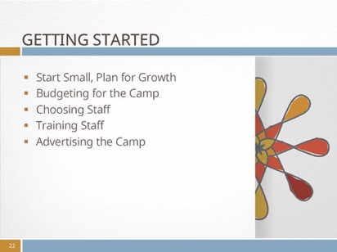 |  | - Start Small, Plan for Growth  - Budgeting for the Camp  - Choosing Staff  - Training Staff  - Advertising the Camp
 | slide 23
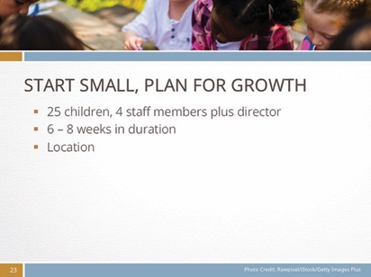 |  | Start Small, Plan for Growth. As you form plans for your summer camp and start thinking about staffing quotas, budget, and weekly activities, consider starting small. For example, managing 25 children is possible with four staff members and the director. While many camps run for eight to 12 weeks (or all but a week or two of the local school vacation period), consider operating a shorter camp the first year—perhaps six to eight weeks. The next year, after you’ve resolved any procedural issues and created a rapport with staff and parents, you can increase your enrollment and length of camp time.  Another consideration when planning for your camp is where you will operate the camp. Ideally you can use the Life Hope Center building or rent a public building such as a portion of a school or public hall that offers the needed facilities. Look around; ask local government officials for ideas and likely costs.
 | Slide 24
Budgeting for the Camp. You’ll need to plan a budget for the camp. Your budget should consist of any rental space needs, salaries, workers’ compensation/insurance, activities fees, t-shirts for each child, promotional products, advertising, food, and emergency funds. Some guidelines appear in Appendix A on page 40. The examples are illustrative only.
Some cities may provide grants to help cover the cost of daycare and payment of student workers. Some offer financial incentives to businesses to hire teens and college-age young people as summer workers.
 | slide 25
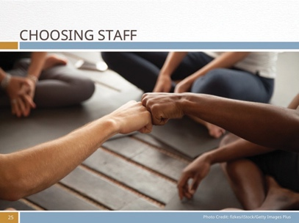 |  | Choosing Staff. Running a summer day-camp program can be rewarding but working with high-energy children all day can be exhausting and requires staff members with strong leadership and management abilities. Choose staff members carefully. Start with people you already know so you can build a team spirit from the beginning. Consider hiring responsible and high-energy teenagers or college students who are willing to work with children and have leadership capabilities.
 | slide 26
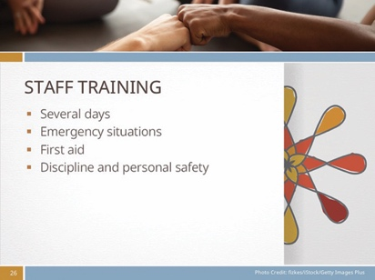 |  | Training Staff. Be prepared to provide several days’ training for your staff. This should include topics such as: safety protocols, how to engage children, learning styles, and day-today challenges of working with children.  Include coursework on dealing with emergency situations. Provide a course in first aid (including CPR), and cover procedures and protocol for emergencies such as how to prepare for dangerous weather and personal safety. Your staff should be intimately familiar with protocol for discipline and personal safety—their own and the children’s—and be able to respond instantly to challenges that can occur, whether a discipline issue or a danger threat. A rule of thumb for staffing formulas is one staff member for every four or five children.
 | slide 27
 |  | Advertising the Camp. Once you’ve decided on where and when you’ll conduct the day camp, what you’ll need to charge for enrollment in order to cover expenses and emergencies, you’ll want to advertise. Start advertising a month or more before school session ends. Create posters to put up in public areas such as the local library, stores, and government offices. Print flyers to send home with children in local schools and to any other religious organizations in the area. Be sure to include the dates and hours of service, age requirements/limitations for children, cost, and a telephone number. Consider taking pictures of the location and posting them on a website for parents and potential clients to examine.

 | Important questions to consider
 | slide 28
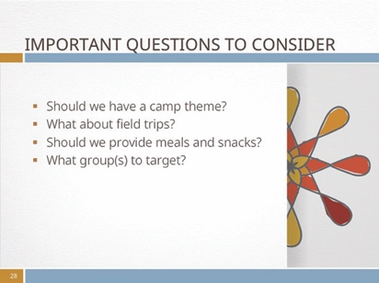 |  | - Should we have a camp?  - What about field trips?  - Should we provide meals and snacks?  - What group(s) to target?
 | Slide 29
Should we have a camp theme?
Parents are more likely to enroll their child in a camp that has a theme related to their child’s interests. A theme could be for the entire summer or for each week of camp. Activities featured during the camp will focus on the theme(s). For example, a camp could be based on nature and the outdoors, science, adventures, or a specific skill such as cooking. A theme (or several themes) helps parents feel that their child is receiving enrichment during vacation rather than just being entertained. See appendix B on page 40 for a list of suggested summer camp themes. Be open for more ideas depending on the skills of your staff and interests in your neighborhood.
 | slide 30
What about field trips?
Field trips related to the theme of the camp can increase the success and popularity of the camp experience. Many cities have museums or activity centers that offer free or low-cost admission for educational organizations. And such field trips ramp up the interest level of the camp. The excursions provide an interesting way to share new experiences. Search online for ideas to fit the theme or interest level of the children in your care.
Transportation for field trips requires logistical and financial planning. Do you have access to a school bus and driver? If not, you’ll need to include the cost of a bus, a van, or public transportation into your budget. When renting a vehicle, ask if the fees include the driver’s fee, insurance, and gas. Ask if there are any hidden fees such as overtime, late returns, etc.
 | Slide 31
Should we provide meals and snacks?
One of the most cost-effective ways to deal with feeding campers is to request that every camper bring a lunch and snack each day. This takes care of any dietary or health restrictions a child may have as well as cutting costs for the center. The camp staff can provide other beverages and special snacks when needed and offer a simple sandwich at a reasonable cost for a child without a lunch. If food must be provided, consider not only the cost of the food but also the expense of hiring someone to cook or prepare it. This will add significantly to the cost of a child’s care.
 | slide 32
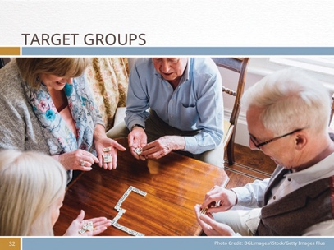 |  | Another Target Group to Consider  While children’s day camps are popular and profitable, don’t overlook the aging population in your community. Consider planning a half-day camp for the elderly. Plan activities such as board games, exercise activities, and weekly excursions for this target audience. This “camp” can run concurrently with the children’s camps as long as the elderly have their own space away from the noise of the children. The two can meet together once or twice a week for “family” time. Or consider running the adult camp during the school year. The adult camp will require fewer staff members per participant and less intensive activities, but you will still need to carefully plan a budget for this program.
 | Another Families First event
 | Slide 33
Sponsor a children’s play group
Once a week open the doors of the Life Hope Center to mothers and their preschool children for a play date and moms’ time out. Many moms have few opportunities to enjoy adult conversation in a relaxed setting while their children play nearby under the supervision of competent teens or adults. This activity offers opportunities for mothers to build relationships with one another and become comfortable with the Life Hope Center staff. Such an activity needn’t involve anything more than a volunteer or two to entertain the children and some chairs and a table for the mothers. However, if you wish, offer the moms and their children healthful snacks such as cut fruits and water or herbal tea.
Such an event is a great opportunity to build trust and record the names and addresses of neighborhood mothers for other future events.
 | slide 34
 |  | Credits

Appendix A: sample budget

 | Week 1 | Week 2 | Week 3 | Week 4 | Week 5 | Week 6 | Total
Rental Space
Transportation | $75 | $120 | $120* | $75 | $120* | $75* | $585*
T-Shirts | Cost of shirt(s) per child/staff times number of children enrolled. Allow two or more shirts per child.
Salaries | Fair wages plus benefits and insurance per week per employee times number of employees. Add 25 percent for contingent expenses such as substitute workers or increased enrollment.
Field Trips/ Activity Fees | Estimated cost of activities/field trips plus 25 percent for emergency contingencies. Round off and average out over total camp time. Prorate for students attending only part of camp.
Advertising
Insurance | Actual cost per child times number anticipated enrolled in program times weeks of camp.
Income per child | Total cost of camp rounded up to allow 25 to 50 percent overrun to build up operating fund.

*Actual costs must be determined per trip.

Appendix b: summer camp theme ideas*

ART, DRAMA, WRITING
Animation
Art from Scratch
Creating Murals
Creative Writing
Digital Media for
Pre-teens
Drama
Fabric, Fashion, and Fun
Journalism
Junior Fashion Designers
Junior Interior Designers
Photography
Public Speaking
Singing and Choral Arts
Sculpture
HEALTH
Cooking and Nutrition
Health and Wellness

LANGUAGE
Introduction to Arabic/
French/Spanish (choose your language)
LEADERSHIP
Community Leadership
NATURE
Archeology
Junior Animal and Nature
Junior Gardner
Wilderness Survival
Friendship
SCIENCE/MATH
Adventures in Math and Science
Around the World
Economics
Museum Explorer
Junior Archeologists
Rocketry

SPORTS
Basketball
Fishing
Fitness
Golf
Junior Sports
Soccer
Tae Kwon Do
Tennis
Volleyball
YOUNG CHILD
Reading/Math Readiness
Getting Ready for School

* For more examples and ideas for summer camp themes, visit this website: http://summercampprogramdisummer.com/100-summer-camp-themes/

Appendix c: sample daily schedule

 | Monday | Tuesday | Wednesday | Thursday | Friday
Day Type | Program Day | Program Day | Trip Day | Program Day | Trip Day
7-9 AM | Before Care | Before Care | Before Care | Before Care | Before Care
9:00 AM | Morning Skit | Morning Skit | Morning Skit | Morning Skit | Morning Skit
9:30 AM | Workshop | Workshop | Bus Leaves | Workshop | Bus Leaves
10:00 AM |  |  | Field Trip |  | Field Trip
10:30 AM
11:00 AM
11:30 AM | Games and Activities | Games and Activities |  | Games and Activities
12:00 PM | LUNCH | LUNCH |  | LUNCH
12:30 PM | Free Play | Free Play |  | Free Play
1:00 PM | Stations | Stations |  | Stations
1:30 PM
2:00 PM
2:30 PM | Games and Activities | Games and Activities |  | Games and Activities
3:00 PM
3:30 PM | Daily Recap | Daily Recap | Daily Recap | Daily Recap | Daily Recap
4:00 PM | Home Time | Home Time | Home Time | Home Time | Home Time
4-6 PM | After Care | After Care | After Care | After Care | After Care

Cognitive ability is based on intellect, memory, and brainpower. Most schools teach kids how to be smarter, however, they fail to teach children how to thrive in social, real-life settings.
See How Children Succeed: Grit, Curiosity, and the Hidden Power of Character. Paul Tough, Mariner Books, Reprint edition (July 2, 2013)
Adapted from Tutoring Mentor Exchange. See http://www.tutormentorexchange.net
These ideas derive from the Canadian Baptists of Western Canada. You can also find helpful resources to keep children safe at the Adventist Risk Management program called Shield the Vulnerable. See shieldthevulnerable.org.
There may be specific guidelines for children-to-adult ratios specific to your geographic region. Please check with your local government agency to confirm their guidelines.
Example adapted from http://safariscience.blogspot.ca/

