a guide to the grant writing process

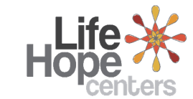
Christine Jeda D. Orillosa-Thurber
MSW, MA
 |  | Leader’s Guide

to the presenter
Thank you for being willing to make a difference in your community and take on the responsibility of teaching this course. You are about to begin a journey that can have an everlasting effect on those who come to your presentation. The Life Hope Center is dedicated to helping people improve their lives through gaining knowledge and applying that knowledge to their lives.

Below are the steps, as well as some helpful hints, to make your presentation a success.

course kit contents:
- Presenter’s guide
- PowerPoint slides

materials needed
- Pens or pencils
- Paper
- Computer (for your presentation)
- Projector and screen
- Tables and chairs
- Sound system (for large classes)

how to use the leader’s guide
This course Leader’s Guide is designed to enable people to teach this course effectively regardless of their experience level. You may be a Human Resources expert or a volunteer who is interested in community education. Use this guide in the way that is best for you and your experience level. You may read it word-for-word or go off notes if you would like.

seminar objectives
The method and requirements of grant writing differ greatly across disciplines. This short manual attempts to provide a general guide to the grant writing process.
In this manual we focus on the first half of the process, covering the steps that lead to the submission of your grant proposal. In addition, we provide web resources that, although may not specifically apply to your organization, can be useful in understanding the general procedures of grant writing and in getting you started.

Tips and Guidelines
1. |  |  | Come prepared.  Review the entire content and handout materials before the session. Arrive early for your presentation. Set up your equipment and test everything before the participants arrive.
2. |  |  | Greet the participants as they arrive.  One of our goals is to build relationships within the community. Greeting people as they enter puts them at ease and can open doors for further dialogue.
3. |  |  | Start on time.  The presentations are designed to be less than 1.5 hours. Honor that time frame.
4. |  |  | Welcome students and introduce yourself.  This introduction should take only 30 to 60 seconds.
5. |  |  | Introduce the topic of the presentation.  A brief introduction appears in the script under slide 2. Keep it short. Introductions should get the participants’ attention, not bore them.

6. |  | Give the PowerPoint presentation.  Study the script ahead of time so that your presentation flows smoothly.

7. |  | Introduce and distribute the quiz.  Detailed instructions are given in the script. Have the participants work in small groups of two to four, discussing and completing the quiz together. (If the nature of your group warrants it, lead the discussion of the quiz questions from the front, soliciting responses from the participants.) Give the participants about 20 minutes to complete the quiz. Monitor the participants’ progress, adjusting the time as needed to allow them time to complete the worksheet. Then call them back together as a group and discuss the answers using the answer key.
8. |  | Thank the participants for coming and visit with them as they are leaving.

WELCOME

 | Slide 1
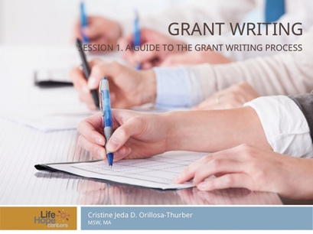 |  | Welcome to the A Guide to Grant Writing Process seminar. The method and requirements of grant writing differ greatly across disciplines. This short manual attempts to provide a general guide to the grant writing process.
 | Slide 2
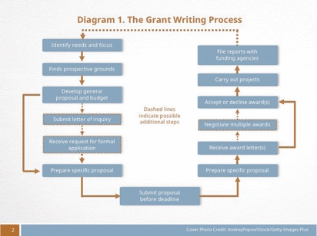 |  | We will focus on the first half of the process, covering the steps that lead to the submission of your grant proposal. In addition, we provide web resources that, although may not specifically apply to your organization, can be useful in understanding the general procedures of grant writing and in getting you started.  Diagram: The Grant Writing Process. Retrieved from http://writingcenter.unc.edu/handouts/grant-proposals-or-give-me-the-money/
 | Social and needs assessment
 | Slide 3
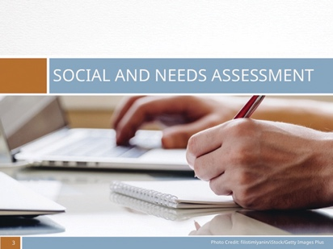 |  | Social and needs assessments identify the problem or needs of a community and provide data to substantiate that need. Its purpose is twofold: to determine the issues and needs of the communities that your organization serves, while, at the same time, assessing the role that your organization plays in meeting those needs.  Social and needs assessment can be identified via group processes or individual processes. Group processes include focus groups, town hall meetings, and nominal group processes (voting), whereas individual processes include interviews, surveys, and observations.
 | THINGS TO KEEP IN MIND
 | Slide 4
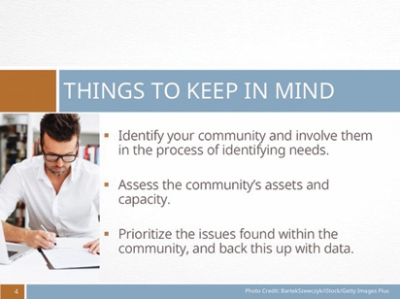 |  | Identify your community and involve them in the process of identifying needs. They know best the issues they face and more than likely know the solution as well!  Assess the community’s assets and capacity. The community is a great resource, and funders like to see the community involved in bringing about solutions.  Prioritize the issues found within the community, and back this up with data.
 | Questions TO ASK
 | Slide 5
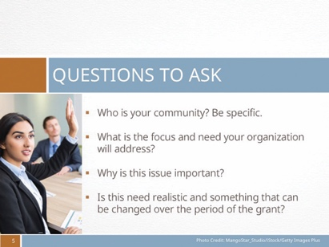 |  | - Who is your community? Be specific.  - What is the focus and need of the community that your organization will address?  - Why is this issue important?  - Is this need realistic and something that can be changed over the period of the grant?

 | Prospective Grants & funders
 | Slide 6
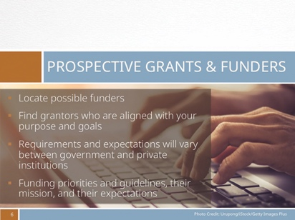 |  |  | Locating possible funders can be a time-consuming process; however, it is key in the grant-writing process. It is important to find grantors who are aligned with your purpose and goals, as this will not only help narrow potential grants and funders for your organization but will also increase your chances to be funded.  Listed on the following slide are a number of resources regarding grant programs. Keep in mind that grants can be funded by the government or by a private institution and that requirements and expectations will vary. Thus, it is important to thoroughly research the grantor, their funding priorities and guidelines, their mission, and their expectations.
 | RESOURCES
 | Slide 7
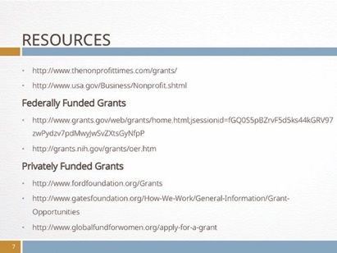 |  |  | - http://www.thenonprofittimes.com/grants/  - http://www.usa.gov/Business/Nonprofit.shtml  Federally Funded Grants  - http://www.grants.gov/web/grantns/home.html;j sessionid=fGQ0S5pBZrvF5d5ks44kGRV97zw P ydzv7pdMwyJwSvZXtsGyNfpP  - http://grants.nih.gov/grants/oer.htm  Privately Funded Grants  - http://www.fordfoundation.org/Grants  - http://www.gatesfoundation.org/How-We-Work/ General-Information/Grant-Opportunities  - http://www.globalfundforwomen.org/apply-for-a-grantProofread
 |  | The grant proposal
 |  | Slide 8
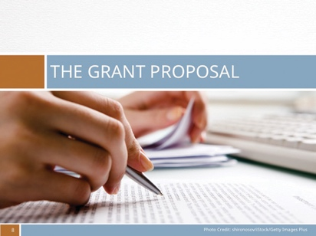 |  |  |  | The information included in grant proposals varies from organization to organization, depending on guidelines and application instructions. It is important that you follow application instructions carefully and that you familiarize yourself with grant guidelines as each proposal request has its own specific requirements and may use different terminology. Nevertheless, all applications or proposal requests hold common components including a cover letter, executive summary, a problem or needs statement, project design, and a program budget.

 | Slide 9
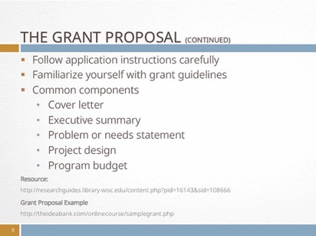 |  | It is important that you follow application instructions carefully and that you familiarize yourself with grant guidelines as each proposal request has its own specific requirements and may use different terminology.  Nevertheless, all applications or proposal requests hold common components including a cover letter, executive summary, a problem or needs statement, project design, and a program budget.
 | COVER LETTER
 | Slide 10
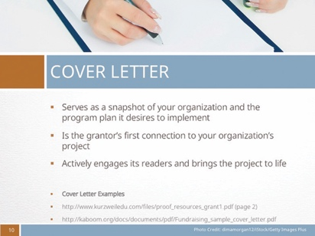 |  | Not to be confused with the executive summary, the cover letter serves as a snapshot of your organization and the program plan it desires to implement. It is often the grantor’s first connection to your organization’s project.  Thus, a cover letter that actively engages its readers and brings the project to life is key. Included in your cover letter is a brief summary of your organization, a one- to two-sentence description of your project, the proposed dollar amount requested, and the name and contact information of the individual spearheading the grant proposal.

 |  | EXECUTIVE SUMMARY
 |  | Slide 11
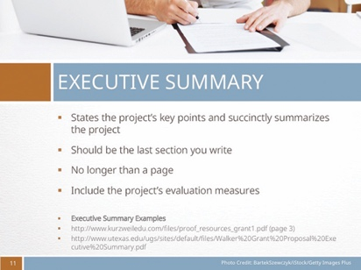 |  |  |  | The Executive Summary states the project’s key points and succinctly summarizes the project. Although placed before the actual proposal, the executive summary should be the last section you write. No longer than a page, it includes the project’s target population, the need the project addresses, its goals and objectives, the proposed funding amount requested, and a short description of the organization’s qualifications and background. In addition, be sure to include the project’s evaluation measures.
 |  | NEEDS OR PROBLEM STATEMENT
 |  | Slide 12
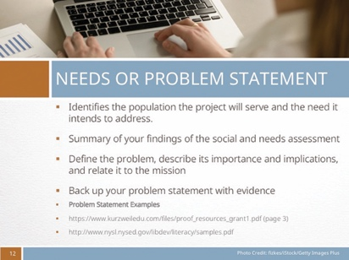 |  |  |  | The problem statement, or statement of need, identifies the population the project will serve and the need it intends to address. This is where you summarize your findings of the social and needs assessment that were previously conducted. In the problem statement, you define the problem, describe its importance and implications, and relate it to the mission of your organization and funder.  Back up your problem statement with evidence by using comparative data to help build a case as to why your organization is focusing on this need. Include tables or graphs that are helpful in summarizing the existing data and gaps in research you have found.
 |  | PROJECT DESIGN
 |  | Slide 13
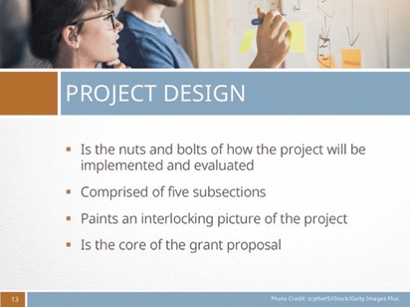 |  |  |  | The project design is the nuts and bolts of how the project will be implemented and evaluated.  Comprised of five subsections (program objectives, methods, staffing/administration, evaluation, and sustainability), the project design paints an interlocking picture of the project as a whole and is the core of the grant proposal.
 | PROGRAM OBJECTIVES
 | slide 14
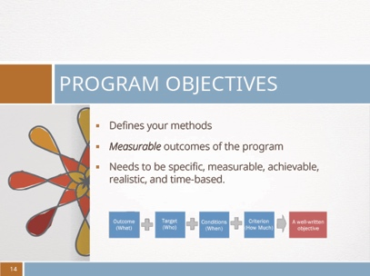 |  |  | Program objectives are an important part of your proposal as they define your methods. Often confused as goals (a broad and timeless statement of a long-range program purpose), objectives are the measurable outcomes of the program that need to be specific, measurable, achievable, realistic, and time-based.

 | four types of objectives
 | slide 15
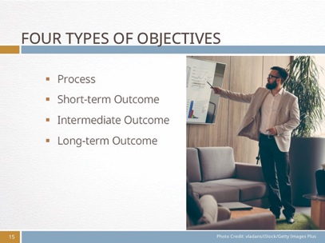 |  | Process: Deals with how you implement your program  Short-term: Deals with the impact of your program (Often addresses change in knowledge, attitudes, or beliefs)  Intermediate: Deals with the impact of your program (Often addresses change in behaviors)  Long-term: Deals with the impact of your program
 | EXAMPLE
 | slide 16
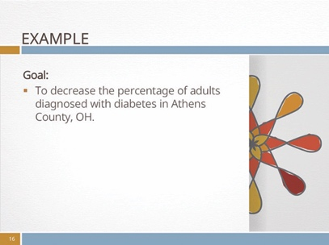 |  | Goal:  To decrease the percentage of adults diagnosed with diabetes in Athens County, OH.
 | slide 17
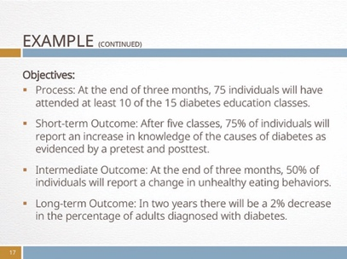 |  | Objectives:  Process: At the end of three months, 75 individuals will have attended at least 10 of the 15 diabetes education classes.  Short-term Outcome: After five classes, 75% of individuals will report an increase in knowledge of the causes of diabetes as evidenced by a pretest and posttest.  Intermediate Outcome: At the end of three months, 50% of individuals will report a change in unhealthy eating behaviors.  Long-term Outcome: In two years there will be a 2% decrease in the percentage of adults diagnosed with diabetes.
 | how
 | slide 19
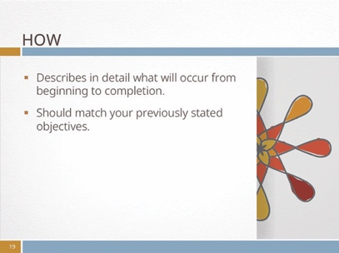 |  | Your methods section describes in detail what will occur from the time the project begins to its completion. It should match your previously stated objectives.
 | when
 | slide 20
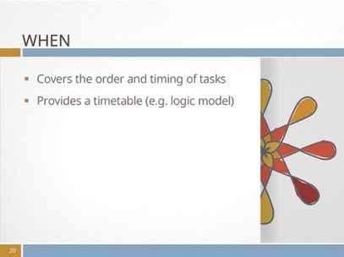 |  | Your methods section should also cover the order and timing of tasks that you plan to implement. Providing a timetable (e.g. logic model) in this section provides another snapshot of your project and makes it easier for potential funders to visually see the projected timeline of the project.

 | why
 | slide 21
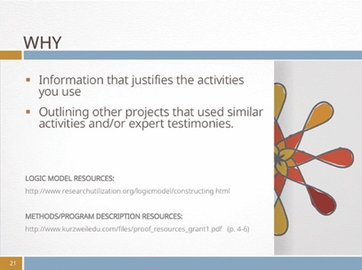 |  | Including a section with information that justifies the activities you use in your project is key in delineating the effectiveness and appropriateness of the activities chosen.  This is often done through outlining other projects that used similar activities and/or expert testimonies.
 | STAFFING/ADMINISTRATION
 | slide 22
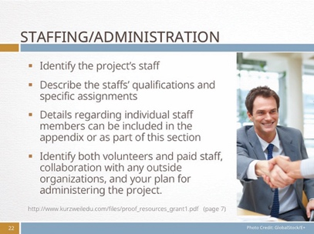 |  | This section is devoted to identifying the project staff mentioned in the methods section and in describing the staffs’ qualifications and specific assignments.  Details regarding individual staff members (e.g. practical experience, level of expertise, educational background, recruitment strategies, etc.) can be included in the appendix or as part of this section.  Remember the importance of identifying both volunteers and paid staff, noting, among other things, specific responsibilities and tasks of volunteers, staff already employed by your organization or recruited for project purposes, collaboration with any outside organizations, and your plan for administering the project.

 | EVALUATION
 | slide 23
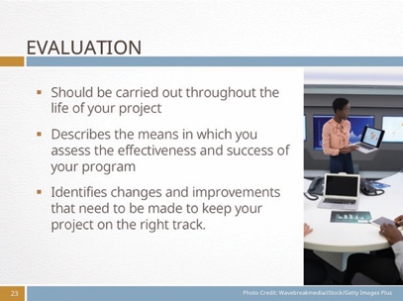 |  | The evaluation section should be carried out throughout the life of your project.  It describes the means in which you assess the effectiveness and success of your program and identifies changes and improvements that need to be made to keep your project on the right track.
 | Two types of evaluations
 | slide 24
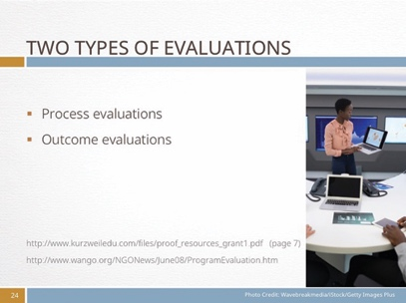 |  | There are two types of evaluations:  - Process evaluations look at how, when, and where your project is set and are often conducted early on.  - In contrast, outcome evaluations are conducted after the conclusion of a program and identify whether or not a project was successful in meeting its objectives.
 | SUSTAINABILITY
 | slide 25
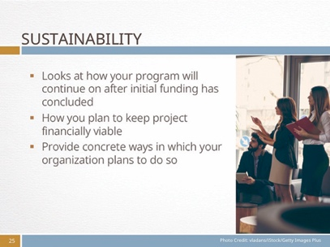 |  | Sustainability looks at how your program will continue on after initial funding has concluded.  Grantors often want to know how organizations plan to keep projects financially viable. Thus, it is important that you provide concrete ways in which your organization plans to do so.
 | Sustainability: Three main areas
 | slide 26
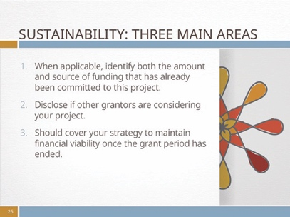 |  | Generally speaking, the sustainability section covers three main areas:  1. When applicable, identify both the amount and source of funding that has already been committed to this project.  2. If other grantors are considering your project, disclose this in your proposal.  3. This section should cover your organization’s strategy to maintain financial viability once the grant period has come to an end.
 | BUDGET
 | slide 27
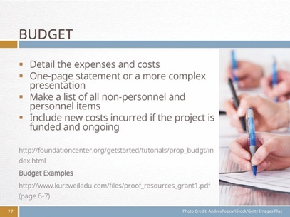 |  | The budget details the expenses and costs of the proposed project, ranging from staff and personnel salaries to non-personnel items, such as office space rentals, advertising, evaluations, etc.  Depending on your project and its needs, your budget may be a simple one-page statement of expenses and revenue, or it may be a more complex presentation that might include notes on the various expenses and revenue or a summary of project support.  When preparing the budget, go through your proposal narrative, making a list of all non-personnel and personnel items related to the project’s operation. Include both new costs incurred if the project is funded and ongoing expenses that may be allocated to the project once it is funded.
 | conclusion
 | slide 28
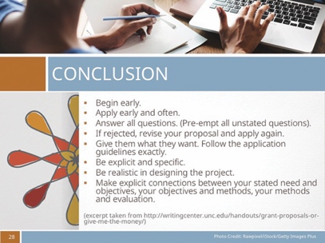 |  | In conclusion, here are some general tips that should help you through the grant writing process:  - Begin early.  - Apply early and often.  - Answer all questions. (Pre-empt all unstated questions).  - If rejected, revise your proposal and apply again.  - Give them what they want. Follow the application guidelines exactly.  - Be explicit and specific.  - Be realistic in designing the project.  - Make explicit connections between your stated need and objectives, your objectives and methods, your methods and evaluation.
 | slide 29
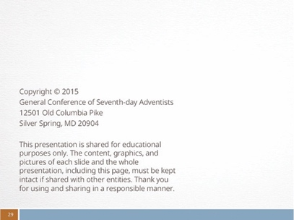 |  | Credits

